But I do not account my life of any value nor as precious to myself,
if only I may finish my course and the ministry that I received from the Lord Jesus,
to testify to the gospel of the grace of God.
Acts 20:24 ESV

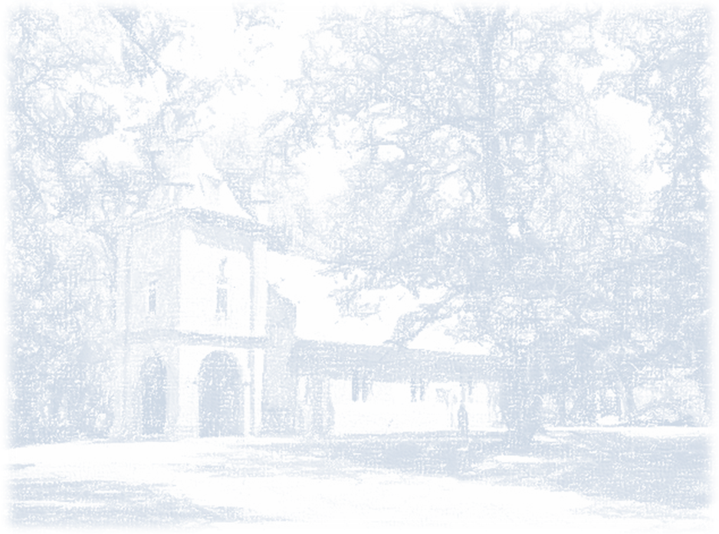

Please join us at a reception
to honor and celebrate our beloved Rector,

The Reverend Dr. Stephen Paul Rowles

on the occasion of his retirement

Sunday, August 26, 2018 at 11:00 am
St. Peter’s Parish Church
Richardson Hall

A light buffet meal and beverages will be served

Please RSVP no later than August 17 to
joycepeterson8@gmail.com or
(804) 690-9764

If you would like to contribute toward a gift from the parish,
donations may be delivered to the church office or mailed to:

Mr. Stuart Burnett, Treasurer
St. Peter’s Parish Church
8400 St. Peter’s Lane
New Kent, Virginia 23124

Checks should be made out to St. Peter’s Church and indicate “Rector’s Gift” on the memo line.

